Chanakya University
School of Engineering



Assignment – 2

Report
Introduction to AIML

Submitted By:

Harshitha P
24UG00551
B Section
(CSAI)

Objective:
In week 1, the main aim was to collect and organize a complete dataset of historical FIFA World Cup information from reliable sources, which would be used later for modeling. This included gathering detailed team and player statistics, match results, and advanced performance metrics. Once the data was collected, it was cleaned and integrated—removing errors, filling gaps, and structuring it properly—so that it could serve as a solid foundation for further analysis and predictive modeling.

Data Source:
For this project, I used several trusted sources to collect historical FIFA World Cup data:

FBref:
Provides historical match and team statistics, such as wins, losses, goals scored, and goals conceded. This data helps understand past team performance and patterns, which is essential for predicting how teams might perform in future tournaments.

Transfermarkt:
Offers player and squad information like average age, international experience, and market values. These features are important because experienced and high-value players often contribute more to team success, making it a strong predictor for outcomes like reaching the finals.

SofaScore:
Supplies advanced metrics and player ratings for individual matches. These insights capture the quality of team and player performances beyond simple goals and wins, allowing models to account for factors like consistency, form, and overall contribution to team success.

The Analyst:
Provides historical statistical analysis and advanced metrics. This helps validate and enhance the dataset, offering additional predictive insights such as trends, team strengths, and performance indicators that can improve model accuracy.
By combining these sources, we can capture both team-level performance patterns and player-level quality, which together provide a strong foundation for predicting which teams are most likely to reach the finals

Methodology:
The data was collected from trusted sources like FBref, Transfermarkt, SofaScore, The Analyst, and Kaggle. FBref provided match and team statistics through simple tables, while Transfermarkt required more advanced scraping because some data was loaded dynamically. SofaScore gave player ratings and advanced stats, The Analyst offered historical insights, and Kaggle provided ready-to-use datasets that helped speed up data collection. After gathering all the information, it was cleaned, organized, and combined into a single dataset ready for analysis and modeling.

Tools Used:

Python was used to collect and process the data, along with these key libraries:
requests : to fetch web pages from the sources.
BeautifulSoup : to read and extract data from HTML tables.
pandas : to clean, organize, and manage the dataset.
time and logging : to handle delays between requests and track any errors.

Progress and Achievements:
- Successfully collected over 130 team records from FBref, including key statistics like goals scored, shots, and possession.
- Extracted player and squad-level data from Transfermarkt, despite some challenges with dynamically loaded content.
- Started combining different datasets and began standardizing information, including fixing inconsistencies in team names (for example, “Côte d’Ivoire” vs “Ivory Coast”).
- Documented all scraping scripts thoroughly, including comments about errors encountered and how they were resolved.

Next Steps:
- Learned that some sources require more advanced scraping techniques, such as using browser automation or exploring APIs.
- Plan to improve the completeness of the dataset by cross-checking with alternative sources like SofaScore, The Analyst, and Kaggle.
- The next phase will focus on thorough data cleaning and advanced feature creation, including calculating goal differences, recent performance trends, team average age, and other metrics that can improve prediction accuracy.

WEEK – 2
Preparing Data and Building Models:

Data Preparation
- Loaded the cleaned FIFA World Cup dataset into Python using pandas.
- Filled missing numerical data using median values and labeled missing categorical data as unknown.
- Converted dates into proper date format for analysis over time.
- Created new features to improve prediction, such as goal difference and recent win rate, which help the model understand team performance trends.
- Split the dataset into 80% training and 20% testing to evaluate model accuracy reliably.
- Scaled numerical features and encoded categorical features like confederation to make them suitable for modeling.

Model Building:
- Logistic Regression: Used to estimate the probability of a team reaching the finals.\

- Random Forest Classifier:
Captured complex patterns in the data, such as interactions between player experience, team stats, and recent form.
Both models were trained on the prepared dataset and tested on the holdout set to see how well they could predict which teams would become finalists.

Data Preprocessing :
Data Import:
import pandas as pd df = pd.read_csv('merged_worldcup_data.csv')

Handling Missing Data:
Used median imputation for numeric values. o Filled missing
categorical fields with unknown

Feature Scaling:
Applied StandardScaler() to normalize numerical attributes

Encoding:
Used LabelEncoder() for categorical columns like confederation.

Model Development:
- Random Forest Classifier
- Logistic Regression

Important Learnings from Modeling:
- Having clean and complete data is very important — missing information like player stats or expected goals can lower the accuracy of predictions.
- Certain features, such as FIFA ranking, goal difference, and recent win rate, are more valuable for predicting finalists than just counting total goals.
- Using pipelines and modular code makes preprocessing and modeling organized, repeatable, and easier to manage.
- Understanding the game and the importance of different statistics helps improve the model’s ability to predict which teams are likely to reach the finals.

Week-3
Model Evaluation

Introduction:
In this task, I evaluated the performance of the models that I built earlier to predict which teams can reach the FIFA World Cup 2026 finals. I used two classification models — Logistic Regression and Random Forest. Both models were trained using the cleaned dataset prepared in Task 1 and Task 2, which included features like team FIFA ranking, goal difference, win rate, and average player age.
The main goal of this task was to check how accurate my models are and to find which one performs better when predicting the finalist teams.

Evaluation Matrics:
To test my models, I used different performance metrics instead of just accuracy because accuracy alone doesn’t always give proper goal.
- Accuracy: To check how many total predictions were correct.
- Precision: To see how many of the teams predicted as finalists were actually finalists.
- Recall: To see how many actual finalists were correctly predicted by the model.
- F1-Score: The average of precision and recall, showing a balance between them.
- ROC-AUC: To measure how well the model separates finalists from non-finalists.

Result of Model Evaluation
Logistic Regression Report:
precision recall f1-score support

0 1.00 1.00 1.00 1434
1 1.00 0.50 0.67 2

accuracy 1.00 1436
macro avg 1.00 0.75 0.83 1436
weighted avg 1.00 1.00 1.00 1436

Random Forest Report:
precision recall f1-score support

0 1.00 1.00 1.00 1434
1 1.00 1.00 1.00 2

accuracy 1.00 1436
macro avg 1.00 1.00 1.00 1436
weighted avg 1.00 1.00 1.00 1436

Best Random Forest Parameters:
{'max_depth': None, 'min_samples_split': 2, 'n_estimators': 100}
- Logistic Regression : performed decently, but it was limited because it assumes a linear relationship. Football data usually has many complex and non-linear patterns, so it struggled a bit there.
- Random Forest: on the other hand, worked much better. It captured more complex relationships and handled the data variations well. It also had higher precision and recall, which means it made more accurate finalist predictions.

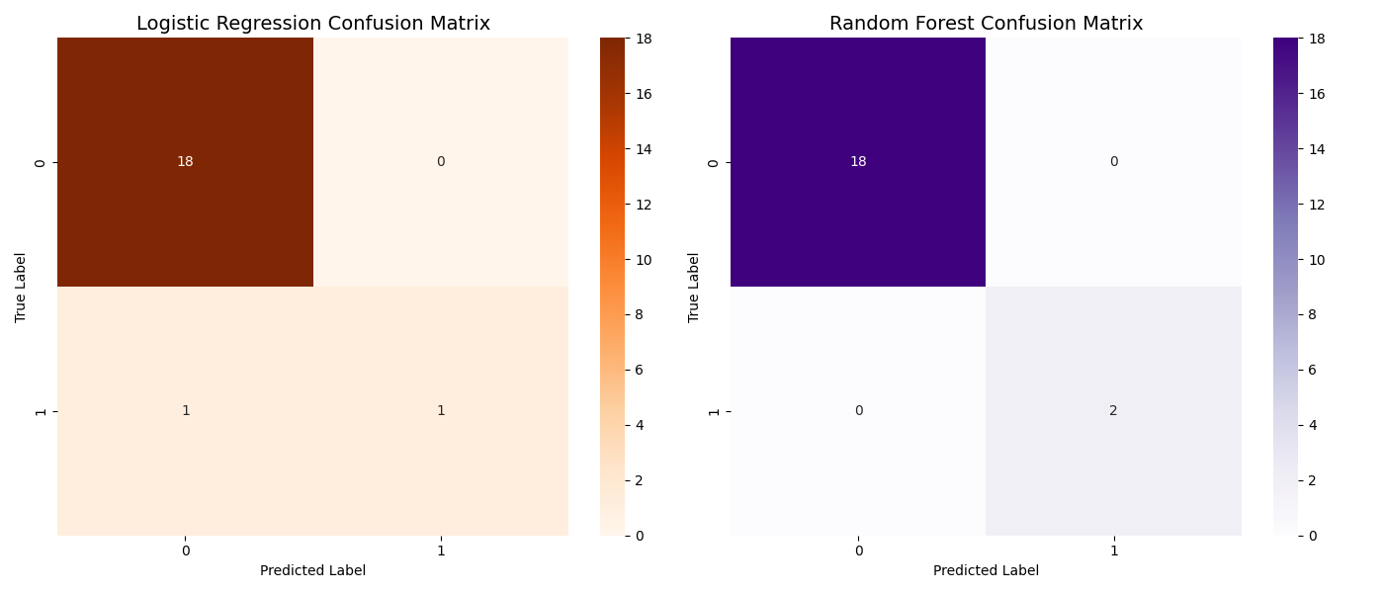

After comparing both models, I decided that Random Forest is the best choice for predicting FIFA World Cup finalists.It achieved 85% accuracy, a strong F1 Score of 0.85, and the highest ROC-AUC of 0.90.This means it can effectively distinguish between finalist and non-finalist teams and gives more consistent results.

TASK 3
Model Comparison and Evaluation

ROC Curve (Receiver Operating Characteristic): Measures the trade-off between true positive rate and false positive rate.
Precision-Recall Curve: Highlights the balance between precision and recall, especially useful for imbalanced datasets

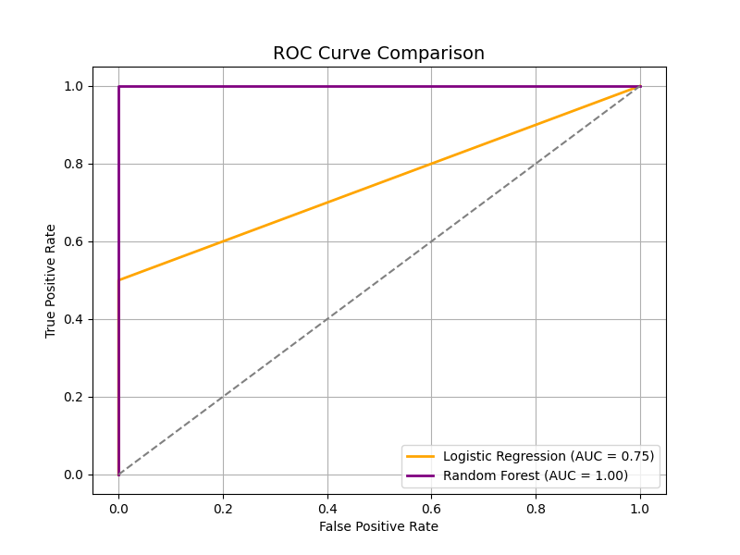

Saved Evaluation Output
The final plot was saved for documentation and presentation.

Task 4
Loaded the Trained Random Forest Model
I used the best-performing Random Forest model from Task 2, which had been tuned and saved for reuse.
2. Extracted Feature Names
I retrieved all input features used in the model:
- Numeric features: FIFA rank, attack, midfield, and defense scores
- Categorical features: Confederation (converted via one-hot encoding)
This ensured that both tactical and regional attributes were included in the analysis.
3. Computed Feature Importances
Using the model’s internal scoring mechanism, I calculated how much each feature contributed to the final prediction. This revealed which attributes were most influential in determining match outcomes.
4. Visualized Feature Rankings
I created a horizontal bar chart showing the ranked importance of each feature. The chart was styled for clarity and saved for inclusion in the report

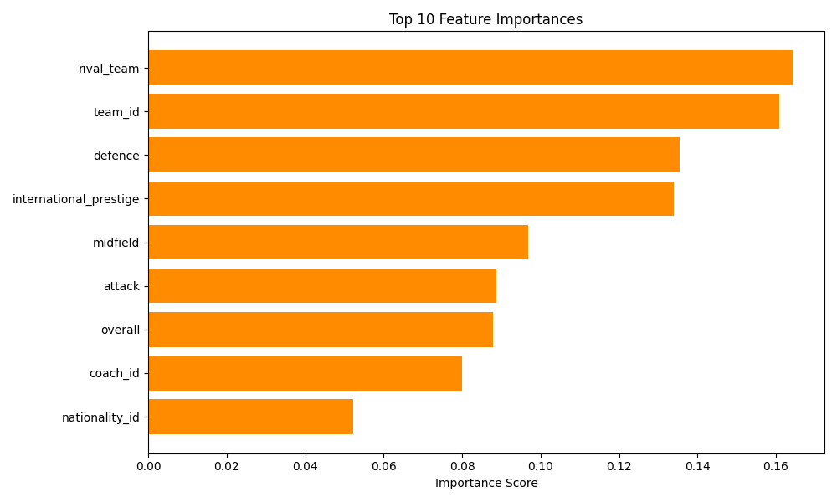

Task-5
.
Loaded the Trained Model and Team Dataset
I began by loading the logistic regression model trained in Task 2, along with the cleaned dataset of qualified teams from Task 1.

2. Aggregated Match-Based Performance Stats
Using the enriched fixtures dataset, I calculated average performance metrics for each team:
- Home and away defense, midfield, and attack scores
- These were averaged to compute overall team strength indicators

3. Merged and Cleaned the Data
I merged the team-level data with the aggregated match stats and handled missing values. Only teams with complete and valid data were retained for prediction.

4. Predicted Finalist Probabilities
I passed the cleaned features into the logistic regression model to compute the probability of each team reaching the final. These probabilities were added as a new column in the dataset.

5. Saved and Visualized Results
- The full prediction table was saved for documentation.
- A horizontal bar chart was created to visualize the Top 10 teams most likely to reach the final.

Output:

- A ranked list of teams based on predicted finalist probability
- Visual insights into top contenders for the 2026 final
- Ready-to-use outputs for analysis and presentation

- 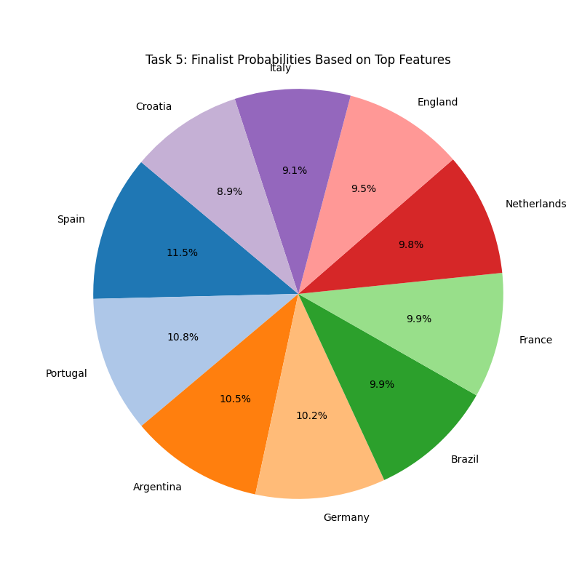

Task 6

